USER PROTOCOL

ID 5831525

Provision of Off Site Storage and Records Management

Lot 1, 2 and 3

Note: that this is a working document and will be updated throughout the lifetime of the contract.

Latest update: 18/03/2026

The Account NI CPA Reference No.

This contract is available to all AccountNI users and all payments related to services delivered are to be made via following AccountNI reference numbers

Lot 1  Start Date - 1st February 2026 | Oasis Group NI Ltd | CPA - 6100089377
Lot 2  Start Date – 1st April 2026 | Oasis Group NI Ltd | CPA - 6100089377
Lot 3  Start Date – 1st November 2026 | Oasis Group NI Ltd | CPA -

CONTENTS PAGE

1. INTRODUCTION
2. SUPPLIER CONTACT DETAILS
3. CONTRACT PERIOD
4. VARIATIONS TO CONTRACT
5. CONTRACT MANAGEMENT ARRANGEMENTS

6. ACCOUNTNI PROCESSES AND CONTACTS
7. INVOICING ARRANGEMENT FOR NON ACCOUNTNI USERS
8. RATE CARD

Annex A List of Participating Bodies

Annex B Contract Documents

- INTRODUCTION
CPD Supplies and Services Division (SSD) have awarded a contract for Off Site Storage for Lot 1, Lot 2 and Lot 3 to Oasis Group NI Ltd.

Annex A lists the participating bodies which may utilise this contract.

NOTE this contract was not advertised in the Official Journal of the European Union and therefore Clients should manage their funding appropriately to ensure EU funds are not used to pay for any services in relation to this contract.

Oasis Group NI Ltd shall provide services for the following Departments:-

LOT 1 Departments
Department for the Economy
Department of Agriculture, Environment & Rural Affairs
Department for Infrastructure
The Executive Office
Department of Health
Belfast Metropolitan College
NI Water
Translink

LOT 2 Departments/CoPE

Department for Communities
Department of Education
Education Authority

LOT 3 Departments

Department of Finance

The Supplier shall provide safe and secure, off-site storage and records management services, including electronic inventory management, for the intake, retrieval, full digital scanning and archiving services and destruction of records as required.

2. SUPPLIER CONTACT DETAILS

OASIS Group NI Ltd

Point of Contact | e-mail address | Telephone No.
Key Account Manager | Paulina Szajewska  pszajewska@oasisgroup.com | 07394560359
Account Manager | David Osborne  dosborne@oasisgroup.com

3. CONTRACT PERIOD

Lot 1 – The contract period is from 1 February 2026 to 31 January 2032 with the option to extend for 2 periods of up to 24 months each.

Lot 2 – The contract period is from 1 April 2026 to 31 March 2032 with the option to extend for 2 periods of up to 24 months each.

Lot 3 – The contract period is from 1 November 2026 to 31 October 2032 with the option to extend for 2 periods of up to 24 months each.

4. VARIATIONS TO CONTRACT

ADDING/REDUCING/REMOVING SERVICES FOR NEW OR EXISTING LOCATION

When adding, changing or removing a service to a building the Client must complete a variation to the contract which must be agreed in advance between the Department and the Supplier.
Variation Form included at Annex B
Costs for additional buildings / services will be as per the rate card. If there is any doubt about cost this can be clarified with the CPD Contract Manager

Over the lifetime of the contract any additional buildings or services can be added / reduced / removed. The Supplier requires three months’ notice for changes to service delivery.
Once a contract variation has been agreed and signed off by both parties (Department and Supplier) please forward a copy to CPD - Collaboration.CPD@finance-ni.gov.uk - for information purposes.

5. CONTRACT MANAGEMENT ARRANGEMENTS

It is essential to the delivery of this Contract that the Supplier has a robust management structure in place to ensure that all performance and day to day contractual matters can be resolved as early as possible so that services to this Contract are not disrupted.

Performance monitoring is key to ensure that value for money is achieved. Poor performance and defaults will be managed in relation to the specific business area.
The Supplier will nominate a Key Account Manager, who will provide regular contact with the Buyer’s Information Managers or their Representatives. The Supplier shall liaise with and have a daily point of contact for the Business Area’s Representative for operational queries.

The Supplier shall, in liaison with the Client’s Information Manager, incorporate into the running of the Contract, measurements which indicate levels of performance. Core Key Performance Indicators (KPIs) have already been identified to support the delivery of the Offsite Storage contract. KPIs are detailed separately in Schedule 10.
Each buyer will appoint a Contract Manager within their business area to oversee the day to day management of the contract. These representatives will be first point of contact for all contractual issues and will meet with the Supplier on a regular basis. The Supplier must ensure that suitable representatives attend all contract review meetings as and when required.
Contract Management and Performance Monitoring will be taken forward in three tiers: -
- Operational management on an ongoing basis between the Buyer’s Business Area Representative and the Supplier.
- Quarterly monitoring review meeting (or earlier by request of the Buyer) between the Buyer’s Information Manager and the Supplier; and
- Annual Contract review between the CPD Contract Manager and the Supplier.
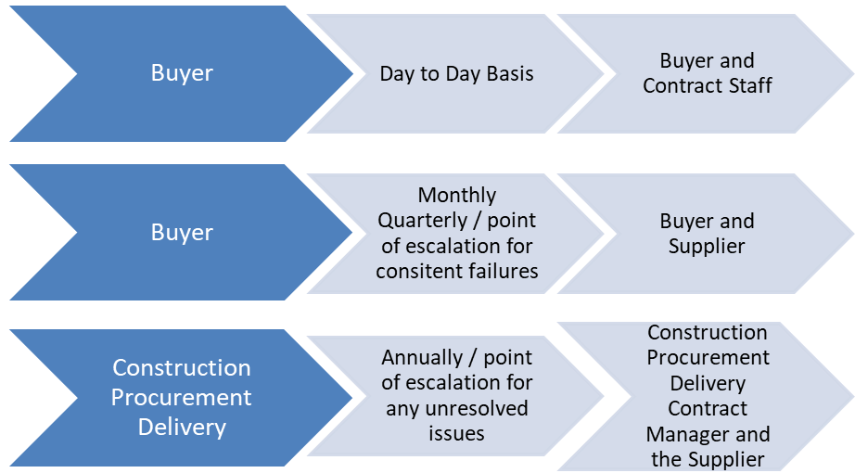

Please see Mid-Tier Schedule 13 (Contract Management) Annex B for further information relating to contract management.
Key Performance Indicators (KPIs), measurement and scoring is detailed in Schedule 10 (Performance Levels).

A Contract Monitoring form (CM01) form will be completed on a quarterly basis to capture the Supplier’s performance on the KPIs across all services being provided based on performance data collated from Stakeholders. The Buyer(s)/CPD may adjust the frequency of these review periods during the life of the Contract depending on the supplier’s performance across the Contract. The Supplier’s performance including any poor performance or areas for improvement will be captured and recorded by the Buyer authorised representative or the CPD Contract Manager. This information will be collated to inform the CM01 form and scored accordingly.

6. ACCOUNT NI PROCESSES AND CONTACTS

Invoicing
E-invoicing will be the method of payment used for this contract.
To meet the requirements of einvoicing the supplier will be instructed to adopt a full No PO-No Pay policy meaning they will;
- not supply goods to departments without advance receipt of an Account NI purchase order number;
- only issue invoices (in pdf format) directly to the Account NI e-invoicing inbox (einvoicing@accountni.gov.uk); and
- only issue invoices with a valid Account NI 10 digit purchase order number beginning with 6.

Account NI will reject any invoices received without an Account NI purchase order number, and/or received by any method other than pdf, directly back to the supplier. Similarly, any invoices received directly or indirectly into the department should be returned to the supplier requesting that the invoice is resubmitted to Account NI.

Ordering
All Purchase Orders must be raised by Premises Officers / Client representative and forwarded to the Supplier to allow them to quote the PO on incoming invoices for the service requested. All Purchase Orders should be linked to the AccountNI reference number (CPA number) detailed at the start of this document.

All available products and services are available to order from the Account NI iProcurement system as catalogue items.
Account NI Contacts
Any queries must be directed to the Account NI Service desk are: 0845 671 3133

Alternatively you can make contact with your AccountNI Business Relationship Manager (BRM).
Contact Account NI
The BRM will:
- act as the formal customer contact for the Department/supplier
- deal with escalated issues
- facilitate the resolution of problems identified by either the Department or the supplier

7. INVOICING ARRANGEMENTS FOR NON ACCOUNT NI USERS
The Supplier will liaise with the individual Non AccountNI Clients to develop
invoicing arrangements.

The Account NI contract numbers are detailed at the start of this document.

9. RATE CARDS

Pricing for services are detailed within the rate card. To access the rate card a non-discourse agreement (NDA) must be completed. The non-disclosure agreement can be downloaded from CPD’s website https://www.finance-ni.gov.uk/articles/supplies-and-services-collaborative-arrangements and is attached at Annex B of this document.

The rate card is classified as Official – Sensitive –Commercial and must be handled in accordance with this classification and must not be forwarded to a third party.

The Buyer is required to check invoices received against the rate card to ensure that the charged amounts are correct. Should there be any discrepancies noted please refer these in the first instance to the Supplier and your Departmental/CoPE representative for resolution.

If the issue remains unresolved the Departmental / CoPE representative shall contact CPD who will offer advice on how the matter may be progressed.

This contract is managed by:

Collaboration Facilities Management Team
Construction & Procurement Delivery
Supplies and Services Division
303 Airport Road West
BELFAST
BT3 9ED
Email: collaboration.CPD@finance-ni.gov.uk

ANNEX A

List of Participating Bodies

The participating bodies listed within this contract are:

Lot 1 - Government Departments, Arms Length Bodies (ALBs) and Non Departmental Public Bodies (NDPBs)
The Executive Office
Department of Agriculture, Environment & Rural Affairs
Department of Health
Department for the Economy
Department for Infrastructure
Belfast Metropolitan College
Northern Ireland Water
Translink

Lot 2 - Government Departments, Arms Length Bodies (ALBs) and Non Departmental Public Bodies (NDPBs)
Department for Communities
Department of Education
Education Authority

Lot 3 - Government Departments, Arms Length Bodies (ALBs) and Non Departmental Public Bodies (NDPBs)
Department of Finance

ANNEX B
Contract Documents

Mid-Tier Schedule 02 (Specification)

Mid-Tier Core Terms

Mid-Tier Schedule 13 (Contract Management)

Mid-Tier Schedule 21 (Variation Form)

Non-disclosure form

