Form CG02 | 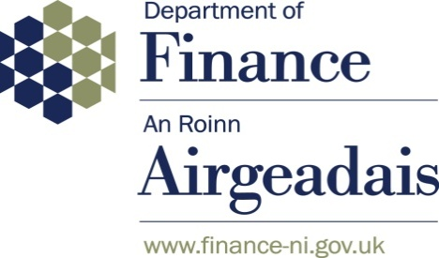

2025-26 WGA

Notification of Completion of the WGA Agreement Process

Name of Body: [PLEASE ENTER HERE]
Body CPID: [PLEASE ENTER HERE]

I certify that, for the purposes of the 2025-26 Whole of Government Accounts, and in accordance with the 2025-26 WGA Guidance:

- I have agreed all balances at 31 March 2026 and transaction streams in the year ending 31 March 2026 with other central government and NI local government bodies, which exceeded £5 million on a gross basis (except for taxation balances with HM Revenue and Customs).
- I acknowledge the requirement to submit the CG-01 form to the Department of Finance for any balances or transactions with GB central government bodies over the £5 million threshold.
- If transactions and balances have not been agreed on a gross basis, details are provided below:
[PLEASE PROVIDE DETAILS HERE]

- Emailed to DoF along with this form are:
  - CG01 forms with any GB central government bodies with whom I have transactions and balances exceeding the £5 million threshold.
  - Supporting papers where there are significant differences (more than £200,000) between amounts recorded by two bodies.
  - CG02 Annex Form ‘Departments’ balances with Local Authorities’ listing any transactions or balances above £1 million with GB local government entities.
[PLEASE ENSURE THESE DOCUMENTS ARE SENT ALONG WITH THIS FORM]

- Amounts not agreed with differences greater than £200,000 are summarised below.
[PLEASE SUMMARISE BELOW & PROVIDE FURTHER DETAILS ON SUPPORTING PAPERS]

Amount | CPID | SCOA | Rationale

- Sub-consolidating Departments’ Declaration [Delete if not applicable]:
All bodies within the departmental consolidation group, and any funds administered by the group, have agreed their 2025-26 transaction streams and balances in accordance with guidance provided by DoF.

Signed by Consolidation Manager: _______________________

Date: ___________

Please note that where electronic signatures are used, they must be a copy of the original signature and the completed form must be sent directly by the Consolidation Manager from their email account.

NDPBs, Health Trusts, Trading Funds and Public Corporations should return this form to their sponsor department by the date agreed with their sponsor department. Sponsor departments should forward the form to wga.afmd@finance-ni.gov.uk by 28 August 2026 in respect of any bodies not included in their consolidated departmental WGA submission.

Local Government bodies should return this form to wga.afmd@finance-ni.gov.uk and LGFinanceBranch@communities-ni.gov.uk by 28 August 2026.

Departments, NI Consolidated Fund, Trust Statements and pension schemes should complete, sign and email this form to wga.afmd@finance-ni.gov.uk by 28 August 2025.

