Form CG03 | 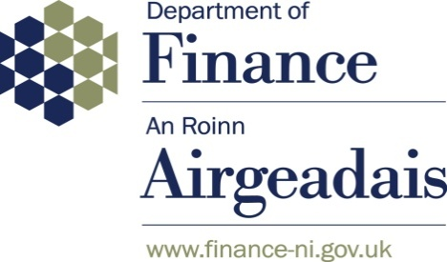

2025-26 WGA Confirmation of Minor Body Status

Name of body: [PLEASE ENTER HERE]

Body CPID: [PLEASE ENTER HERE]
(if one has been assigned)

Minor Body in 2024-25: Yes / No (delete as appropriate)

PLEASE NOTE THRESHOLD OF £30M

I confirm that the information outlined below has been extracted from the statutory accounts for the financial years 2025-26 and 2024-25:

Item | 2025-26  £’000 | 2024-25  £’000

Gross annual expenditure for the year

Gross annual income for the year

Net book value of property, plant and equipment as at 31/03/26 and 31/03/25

Gross assets as at 31/03/26 and 31/03/25

Gross liabilities as at 31/03/26 and 31/03/25

Net assets as at 31/03/26 and 31/03/25

I hereby certify that the above body meets the criteria for being treated as a minor body during 2025-26, whereby amounts are all below £30m. Note – to meet the minor body criteria, this must apply for both years.

Signed:

Consolidation Manager
[ Date ]

Please note that where electronic signatures are used, they must be a copy of the original signature and the completed form must be sent directly by the Consolidation Manager from their email account.

ALBs should return this form to their sponsor department who will forward to DoF by 12 August 2026.

Local Government bodies should return this form to wga.afmd@finance-ni.gov.uk and LGFinanceBranch@communities-ni.gov.uk by 12 August 2026.

Departments and pension schemes should email this form to wga.afmd@finance-ni.gov.uk by 12 August 2026.

Note that bodies who meet the criteria for 2025-26 will be added to the initial list of minor bodies in the 2026-27 Whole of Government Accounts.

